 | LEYTE V ELECTRIC COOPERATIVE, INC.  Brgy. San Pablo, Ormoc City, Leyte  Cellular Phone Nos. Calls Only: Globe: 0917-683-7230  Website: www.leyeco-v.com.ph eMail Address: info@leyeco-v.com.ph |  |  | 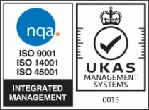  Page 1 of 5
 | Document No.: ISD-FM-0001 | Revision No.: 001 | Effectivity Date: 10/15/2025
 | APPLICATION FOR MEMBERSHIP AND POWER SERVICE CONNECTION

SCO No: __________ SCO Date: ___________ Membership OR Number: _________________ Date Issued: ___________

APPLICANT (Last Name, Given Name, Middle Name, Name Extension)/ (Company/Organization for Juridical)

SPOUSE / NAME OF THE REPRESENTATIVE OF COMPANY/ORGANIZATION (Last Name, Given Name, Middle Name, Name Ext.)

ADDRESS (House Number, Street, Sitio/Purok, Barangay, Town/City, Municipality)

Date of Birth  (MM/DD/YYYY) |  | Contact Number  (XXXX – XXX - XXXX)

Type of Membership  (Please tick the appropriate box) |  | Single | Service Classification  (Please tick the appropriate box) |  | Residential
Type of Membership  (Please tick the appropriate box) |  | Joint | Service Classification  (Please tick the appropriate box) |  | Lower Voltage, Pls specify:
Type of Membership  (Please tick the appropriate box) |  | Juridical | Service Classification  (Please tick the appropriate box) |  | Higher Voltage, Pls specify:

Point of Connection  (Please provide data) | Transformer kVA Rating |  | Type of Application  (Please tick the appropriate box) |  | New Installation
Point of Connection  (Please provide data) | Pole Number |  | Type of Application  (Please tick the appropriate box) |  | Temporary Facility
Point of Connection  (Please provide data) | Feeder Number |  | Type of Application  (Please tick the appropriate box) |  | Meter Transfer
Point of Connection  (Please provide data) | Nearest Meter Number |  | Type of Application  (Please tick the appropriate box) |  | Additional Installation

I/We hereby attest that all the information in the submitted documents herewith attached are true and correct to the best of my/our knowledge and belief.

I/We have read, understood, acknowledged, and accepted the Terms and Conditions set forth by LEYECO V relative to my/our Power Service Connection Application.

I/We understand that my/our Power Service Connection Application may be held pending or cancelled, if already approved, should there be:

  - Protest, conflicting claims of ownership, or any legal issue that may be raised involving the subject account, until and unless finally resolved by the court, appropriate agency, or settled amicably.

  - Proven irregularities in the application and documents submitted.

_________________________________________  APPLICANT  (Signature over Printed Name)  Date Signed: ________________ |  | _________________________________________  SPOUSE  (Signature over Printed Name)  Date Signed: ________________

Received and processed by:  NESTOR A. RANOCO, JR.  Housewiring and Membership Specialist | Checked by:  GHANDA R. BERNANDINO, MPA, DPA  MSD Chief | Approved by:  ANA MARIA LOURDES M. PASTOR, MBM  ISD Manager

TERMS AND CONDITIONS:

The undersigned (hereinafter referred to as the APPLICANT) hereby applies for membership and agrees to purchase electric energy from LEYTE V ELECTRIC COOPERATIVE, INC. thereinafter referred as the “COOPERATIVE”, upon the following terms and conditions:

- THE APPLICANT:

    - Shall pay the Cooperative the amount of Five Pesos (Php5.00) as Membership Fee, if such application is accepted by the Cooperative, will constitute the Applicant’s Membership Fee.
    - Upon payment of membership fee and eventually becomes a member, assumes no personal liability or responsibility for any debt or liability of the Cooperative, and it is expressly understood that under the law his/her private property is exempt from execution for any debt or liability.
    - Agrees to purchase electric energy from the Cooperative not later than six (6) months from the date of electric energy becomes available, and will pay with the ERC approved rates, in accordance with the policies of the Cooperative.
    - Will cause his/her premises to be connected in accordance with the wiring specifications approved by the Cooperative.
    - Shall have all the rights and privileges granted to members under the By-laws of the Cooperative or any amendments thereof and shall comply with and be bound by the provisions of the By-laws of the Cooperative, and such rules and regulation as may be adapted by the Cooperative.
    - Shall participate in the Annual General Membership Meeting (AGMM) and exercise their right to vote during the District Elections.
    - Shall grant the Cooperative, at its request, the necessary rights and easements to construct, operate, replace, repair, and perpetually maintain on the property owned by the Applicant, and in or upon all roads, streets, or highway abutting said property, its line or lines for the transmission or distribution of electric energy, and will execute and deliver to the Cooperative any conveyance, grant, or instrument which the cooperative will deem necessary or convenient for said purposes or any of them. All lines of the Cooperative and switches, meters, and other appliances and equipment constructed or installed by the Cooperative on said property, except so much thereof, if any, as shall be paid for the Applicant, shall at all times be sole property of the Cooperative, and the Cooperative shall have the rights of access to said property to operate, maintain or relocate its facilities, as may be deemed necessary.
    - Shall refrain from installing and/or operating a welding machine, compressor or other similar additional load categorized by the Cooperative and either Commercial or Industrial without prior notice and approval from the Cooperative.
    - Binds to exempt the Cooperative from whatever damages or losses it may incur on account of power interruptions not within or beyond the control of the Cooperative notwithstanding the exercise of reasonable diligence to prevent such occurrence and its immediate restoration.
    - Shall not be allowed to re-sell electric energy for personal profit or gain.
    - Shall be held responsible and liable for tampering, interfering with, or breaking any seals of meters or other equipment of the Cooperative installed on the Applicant’s premises and/or any unlawful acts defined and enumerated under Section 2 of Republic Act No. 7832 otherwise known as the Anti-Pilferage of Electricity, Transmission Lines / Materials Act of 1994.
    - Hereby authorizes entrance to their premises by any authorized representative of the Cooperative to conduct inspection of the electrical installation, meter reading, or meter testing, as well as to confiscate any device used for violations contained in the Republic Act No. 7832.
    - Will attest to the correctness of the load computation as stated in the electrical plan and in the event that any of the statements contained therein is found to be false, the Cooperative reserves the right to deny electricity to the Applicant.
    - Shall be prohibited to extend its lines thru flying connection to other residence and/or establishment per Magna Carta for Residential Electricity Consumers and the Philippine Electrical Code.

- THE COOPERATIVE:

      - Shall not be liable for damages caused by wiring or other accessories installed by the Applicant in his/her premises not in proper condition.
      - Does not guarantee continuous service, but shall use reasonable diligence to provide uninterrupted service, and having used reasonable diligence shall not be liable to Applicant, for damage, for failure in interruptions or suspension or same. The Cooperative reserves the right to suspend services without liability on its part, at such times, for such periods, and in such manner as may in its judgment be required for the purpose of making necessary repairs on the lines or other parts of its system.
      - Is expressly authorized and empowered to remove its property and discontinue furnishing electric energy should Applicant fail to comply with any of the terms and conditions set forth hereof and any rules and regulations of the Cooperative or become delinquent in an account due to the Cooperative.

- The acceptance of this application by the Cooperative shall constitute an agreement between the Applicant and the Cooperative, and the Contract for Electric Services shall continue in force for one (1) year from the date service is made available by the Cooperative to the Applicant, and thereafter as long as the Applicant has need for any electric service on the subject premises.

- That the parties hereto have agreed that this contract be deemed subject to the provisions of Republic Act No. 7832 otherwise known as the Anti-Pilferage Act of 1994 and the Republic Act No. 11361 otherwise known as the Anti-Obstruction of Power Lines Act.

- Violation or non-compliance of any of the above provisions shall constitute a ground for the termination or cancellation of membership.

The acceptance of this/her application shall constitute the agreement between the Cooperative and the Applicant upon the terms and condition set forth above.

JOINT AFFIDAVIT OF POWER SERVICE CONNECTION

I/ We, _______________________________________________________, as an Applicant, filed a power service connection application wherein I engaged the services of Barangay Electrician, _______________________________________________. After having sworn to in accordance with law, do hereby depose and say testify that the Applicant’s power connection is installed per describe specifications below:
INSTALLATION COMPONENTS AS DECLARED
1. Length of Service Connection  Within 50 Meters - _______ Mtrs Over 50 Meters - ________ Mtrs  Across the road | 4. Grounding Wire
  Min Req’ts | Specifications | OR No.
  Type: TW#10 Solid AWG:
  Size:
  Length: 5 Meters
2. Service Drop Wire Specifications | 5. Grounding Rod
  2.1 Type and Size |  | 2.2 Brand/ Make
  Type
     | Columbia |  | Vanguard
     | Phelps Dodge |  | Duraflex
     | Philflex |  | Harrix
     | Durex |  | Unicon
     | Others: Specify
  Size
  Length
  OR #
  Store
  Min Req’ts | OR No.
  Type/ Size: Galvanized Steel:
  Size: 10 mm or ½ inch:
  Length: 5 Ft
3. Service Entrance  3.1 Pole Side  3.2 Type of Lighting  Brand of Wire | 6. Service Pole  (FOR OVER 50 METERS SERVICE CONNECTION / ACROSS THE ROAD/CROSSING NEIGHBOR’S ROOF OR PREMISES)
  Min Req’ts | Specifications/ Quantity | OR No.
  Protection: Circuit Breaker
  Type/ Size: PDX#10
  Length: 14 Meters
  Note: Protection on Pole Side are required for over 100 meters service connection
  Type of Lamp |  | Wattage, Watts
   | CFL
   | LED
   | Incandescent
   | Flourescent
   | Others: Specify
   | Columbia |  | Vanguard
   | Phelps Dodge |  | Duraflex
   | Philflex |  | Harrix
   | Durex |  | Unicon
   | Others: Specify
  Particulars | No. of Poles | OR No.
  Concrete Type
  GI Pipe Single Size Type
  GI Pipe Telescopic Type
  Conduit 1/4” Angle Bar (if the house is more than 18ft in height or 2-Storey and across the road)
7. Other Connections (for Additional Meter Application)

Other/Existing House Connection:
Name of Consumer: ________________________________
Location: _________________________________________
Account No: ______________________________________
Meter No.:________________________________________

- That my house/ establishment is situated _______ meters and does not exceed more than two hundred fifty (250) meters from the tapping pole of LEYECO V which is the maximum length of allowed service drop wire.
- That I shall negotiate and secure the Right-of-Way (ROW) on the areas or premises traversed by the service drop wire from my house/building to the tapping pole.
- That I shall provide all the standard materials, including but not limited to, the service poles that will be installed for every 50 meters of service drop wire and make it sure that the minimum vertical clearance of my SDW should not be less than 18ft from the ground.
- That I concur that my kWh meter shall be installed at the LEYECO V tapping pole and that I shall provide a safety switch or circuit breaker once the service drop wire exceeds 100 meters in length.
- That I am fully informed and aware of the possible low voltage and electrical hazard in the area due to the lengthy line.
- That I shall be responsible in maintaining the line from the service delivery point (kWh meter) up to my household/building as well as keeping it safe from persons and property and that I shall bind to exempt LEYECO V from whatever damages or losses it may incur.
- That I shall bind myself to all duly promulgated rules, regulations, and policies instituted by LEYECO V and other related government and non-government instrumentalities.
- That any violation of the above conditions would mean rejection of my application and/or shall be a cause for disconnection within forty-eight (48) hours from receipt of notice.
- That we are accountable for any fraud regarding the power service connection described above.
- That the undersigned has filed this power service connection free of fraud and any previous obligation of whatever from LEYECO V.
- That we are executing this Joint Affidavit pursuant to existing laws, rules, and regulations relative to such power connection and for whatever lawful purpose and intent this may serve.

IN WITNESS WHEREOF, we have here unto affixed our signatures this _____ day of _________, 20___ at _________________, Leyte, Philippines.
_________________________________  Affiant, Applicant  (Signature over Printed Name)  VALID I.D. Type and No.: _______________  Issued on: __________  Issued at: ___________ | ____________________________________  Affiant, Accredited Barangay Electrician  (Signature over Printed Name)  BRGY. ELECTRICIAN ID No. ___________ Issued on: _______________  Expiry on: _______________ | ____________________________________  Licensed Electrical Practitioner  (PEE, REE, or RME)  (Signature over Printed Name)  PRC ID No.: _______________  Issued on: ________________  Expiry on: ________________

SUBSCRIBED AND SWORN TO before me this _____ day of _______________ 20___ at the _____________________________, Philippines. Affiant exhibited to me his/her Valid ID ________________ indicated below his/her name.

Doc No______________ Notary Public
Page No_____________
Book No_____________
Series No____________

LOCATION OF RESIDENCE

MAP/SKETCH:

RECOMMENDED SERVICE POLE INSTALLATION FOR LINES THAT EXCEED MORE THAN 50 METERS OR LINES WITHIN 50 METERS BUT CROSSES A ROAD OR GO ACROSS THE NEIGHBOR’S ROOF OR PREMISES:
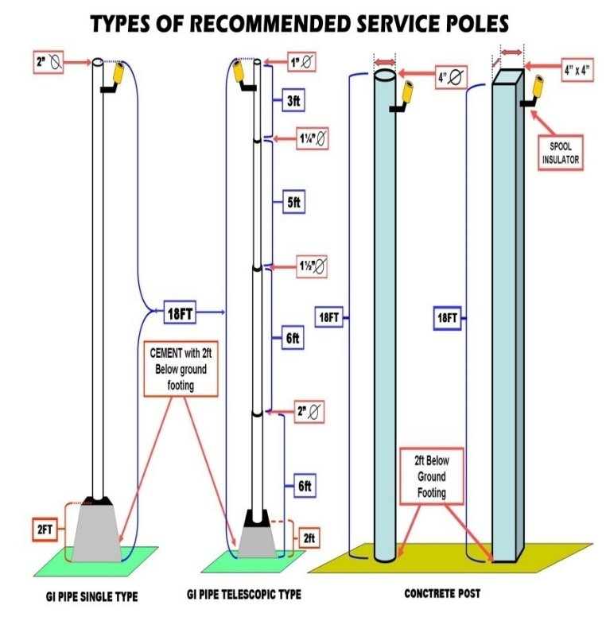
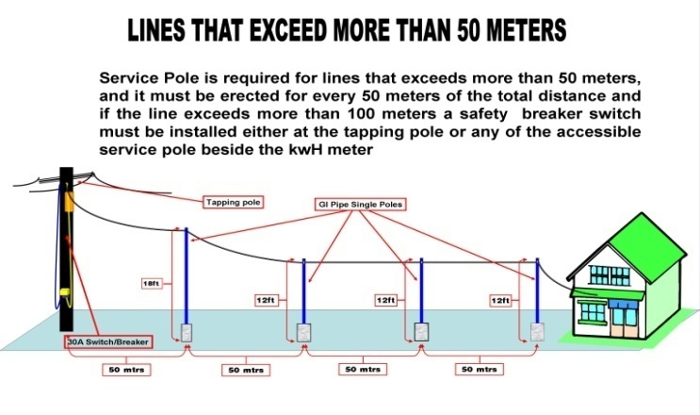
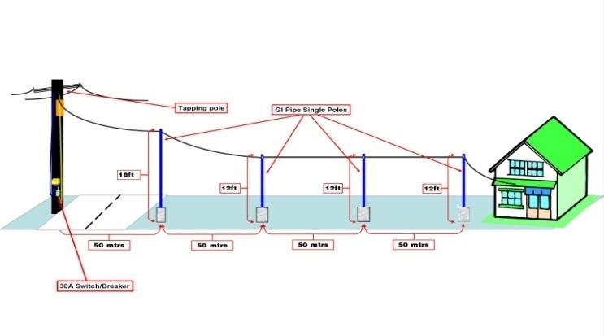
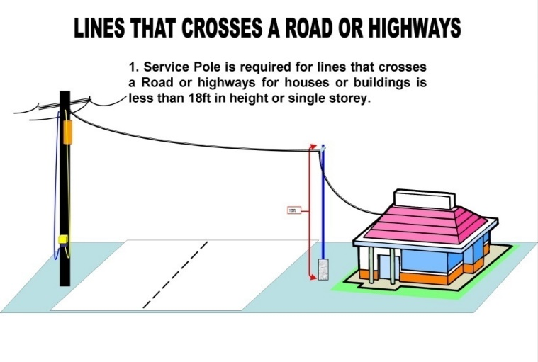
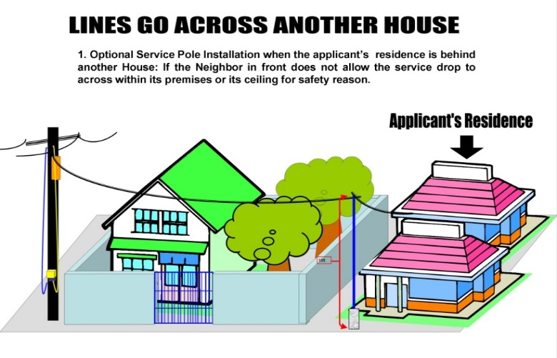

RIGHT-OF-WAY (ROW) CERTIFICATION
PERMIT AND AUTHORIZATION

Date: _______________

TO WHOM IT MAY CONCERN:

In connection with the power service connection application of Mr./Ms.______________________ located at Sitio/Purok_____________, Brgy._________________, Municipality/City______________, Leyte, permission is hereby granted to the Leyte V Electric Cooperative, Inc. (LEYECO V) to enter and use my/ our lot, which will be affected by the installations of electrical connection/s (service drop wire, service pole, etc.) of Mr./Ms.___________________.

Any obstruction due to vegetation (e.g., Trees, Coconut Trees, Banana and the like) situated on the affected lot/s are also included on my permission of this Right of Way (ROW) Permit without cost to LEYECO V.

No. | Lot/ TCT No. | Geographical Location |  |  | Name of Lot Owner | Name of Authorized Representative | Signature of Owner or Authorized Representative
No. | Lot/ TCT No. | Address | Latitude | Longitude | Name of Lot Owner | Name of Authorized Representative | Signature of Owner or Authorized Representative
1
2
3
4
5
6
7
8
9
10

Note: Please attach valid ID of Lot Owner or Authorized Representative and that of the witnesses.

Signed in the Presence of:  Barangay Chairperson/ Official |  | If Public Land/Lot:  LGU Planning/Zoning Official/Representative
Name and Signature (Witness) |  | Name and Signature (Witness)

